17-04-22

**AGENDA**

1. Form input using python selenium
2. Filling a google form using python selenium
3. Python selenium and javascript execution
4. **CLASS TASK**----------Create a Microsoft Form and use Python Selenium for automation. Kindly fill the form ?

******************************************************

**From selenium import webdriver** # To create a web driver

**From selenium.webdriver.common,by import by** # catching hold of the elements

**From selenium.webdriver.common.keys import keys** # to do the click options

& click can be done using dotclick function also

When ever we get a task or work divide the task into small fragments

**BUSINESS LOGIC**

* Open the url
* Find the input box
* Fill the input box
* Click the submit button
* Close the driver

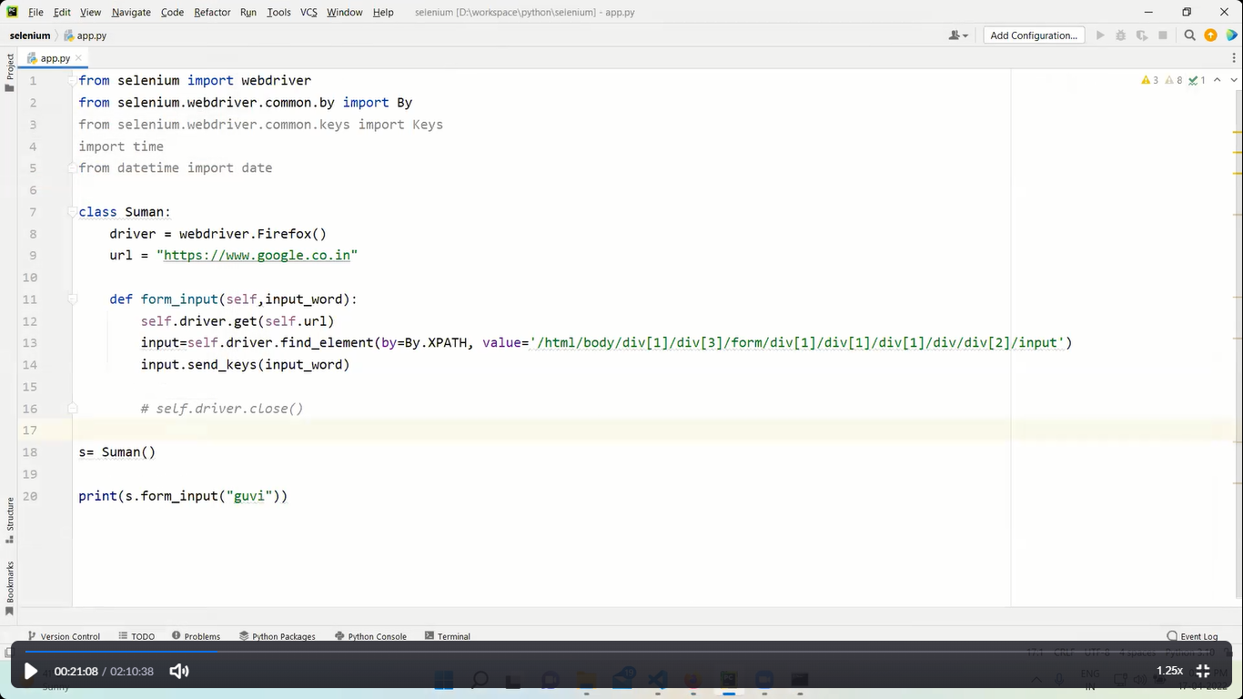

The above program:-

Opened firefox—opened google webpage—using xpath of google search text box—inserted the “guvi” in the google text box

***********************************

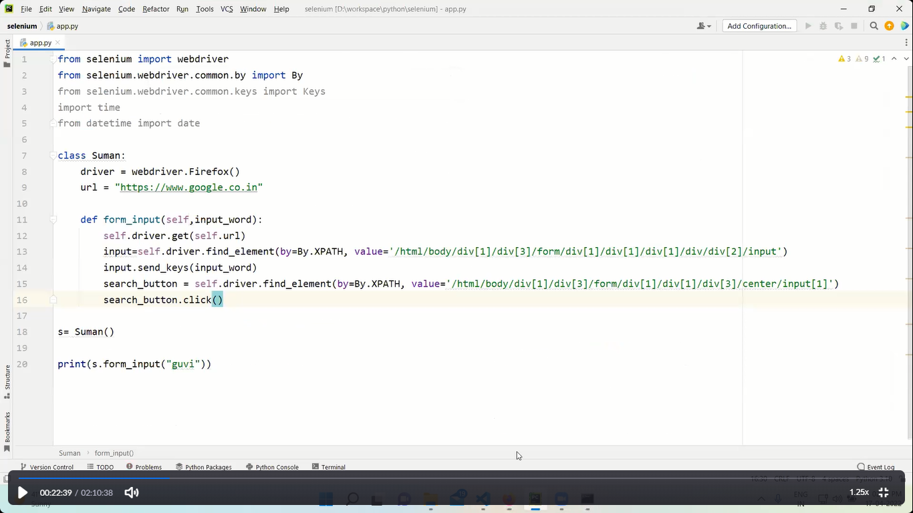

**The above program:-**

Opened firefox—opened google webpage—using xpath of google search text box—inserted the “guvi” in the google text box—again using xpath CLICK on GOOGLE SEARCH button

*****************************

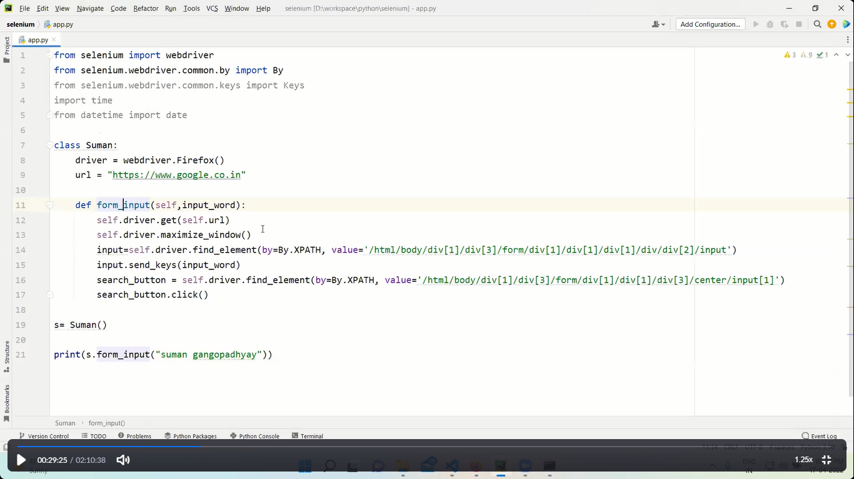

**The above program is about:-**

Opened firefox—opened google webpage—using xpath of google search text box—inserted the “guvi” in the google text box—again using xpath CLICK on GOOGLE SEARCH button-------THIS IS FOR MAXIMIZE THE WINDOW

**********************************

**NOTE:-**

* time.sleep(5) = use this bcoz most of the webpages are highly javascripted so give it some time to load & loading is dependent on network speed and server load
* always remember while automating on google forms in some fields the xpath or class doesn’t work bcoz google don’t support the automated form filling so check those before writing the code
* before writing the code always check the xpath,class names and id properly just in case it got updated

*************************************************************************

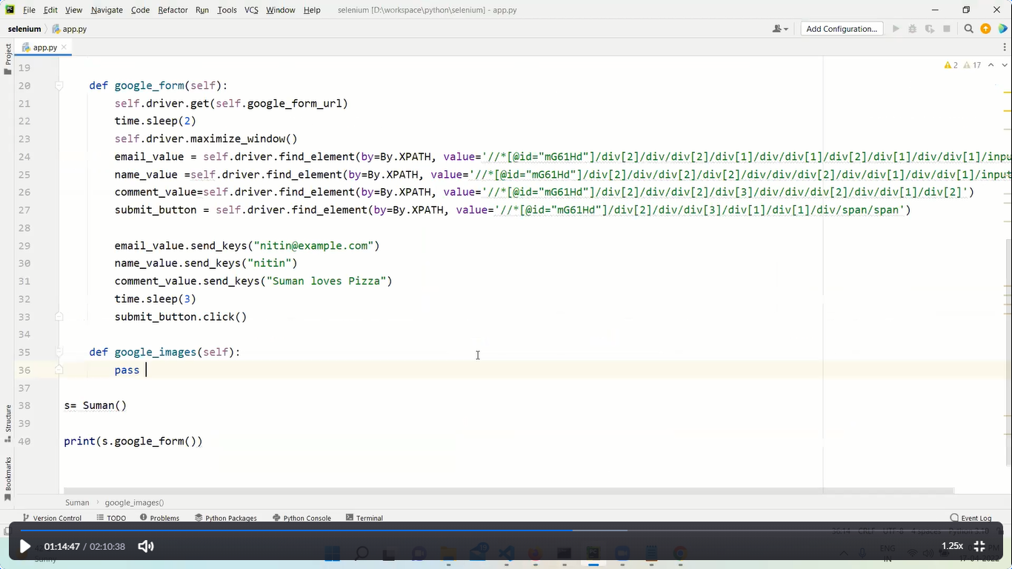

**Above code is for google form filling**

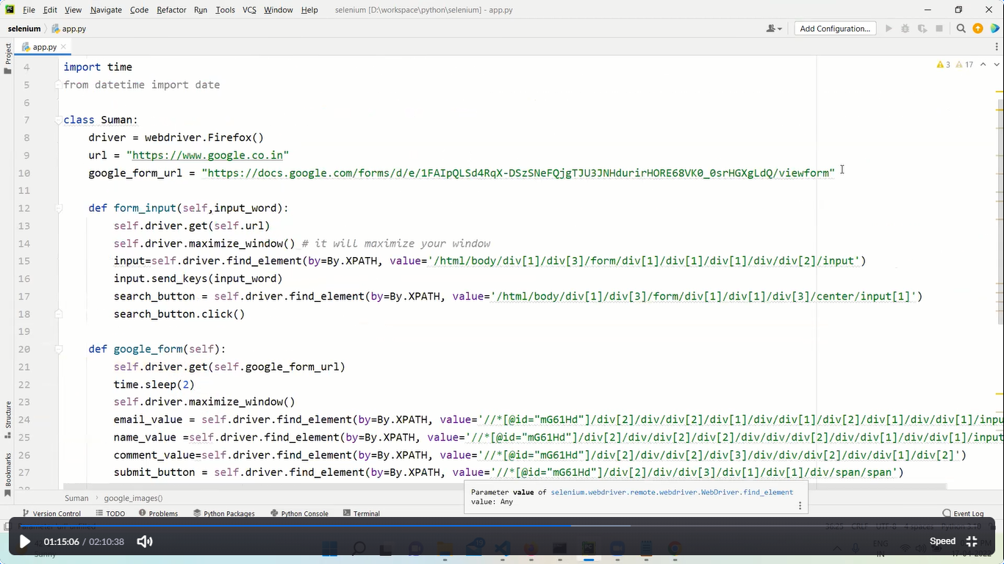

**********************************************************************************

**self.driver.execute_script(“window.scrollTo(0,document.body.scrollHeight);”)**

The above line is to scroll the google web page from top i.e 0 to end of the page

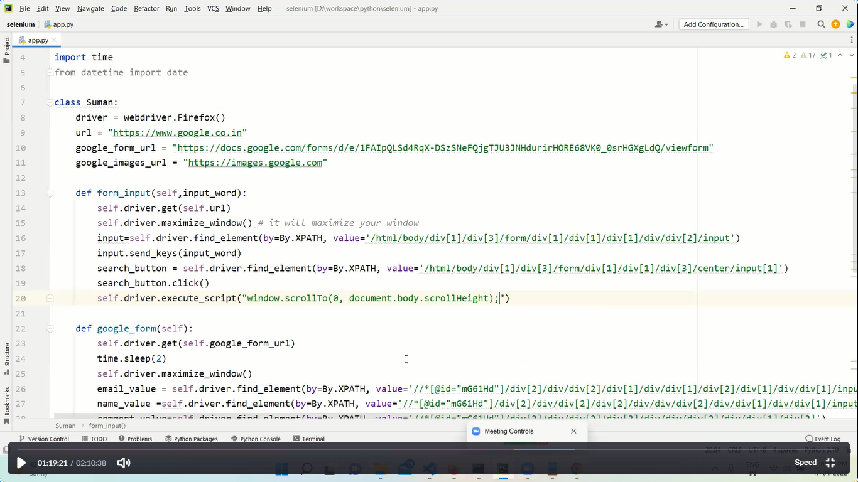

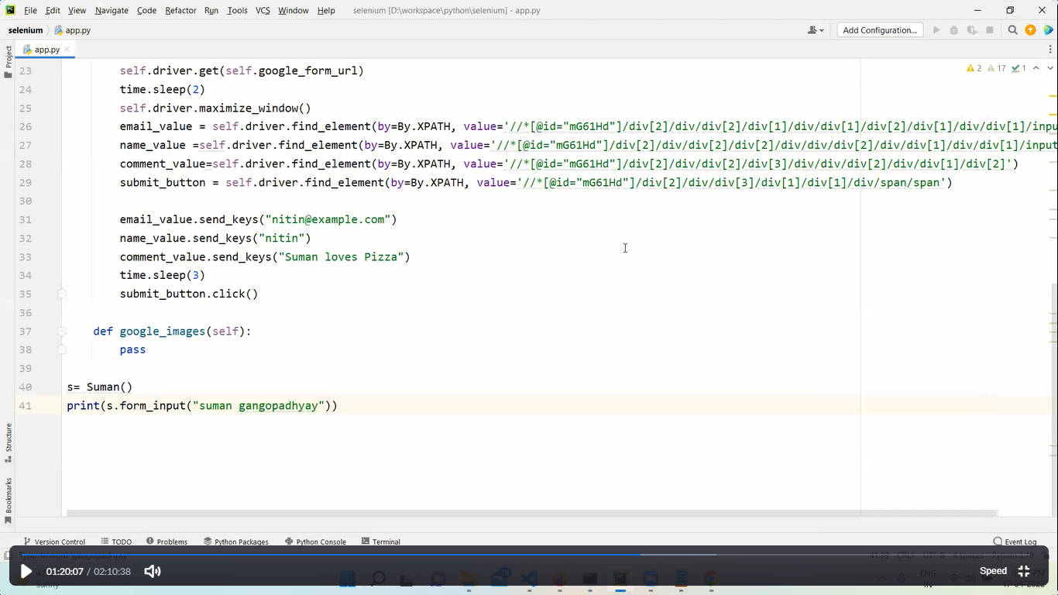

******************************************************************************

Using python selenium the below programs shows

We created a js i.e javascript and displayed a pop up message

& this is where the actual problem is as for example hackers use the python selenium and in that they use i.e the call the javascript and do all unnecessary stuff

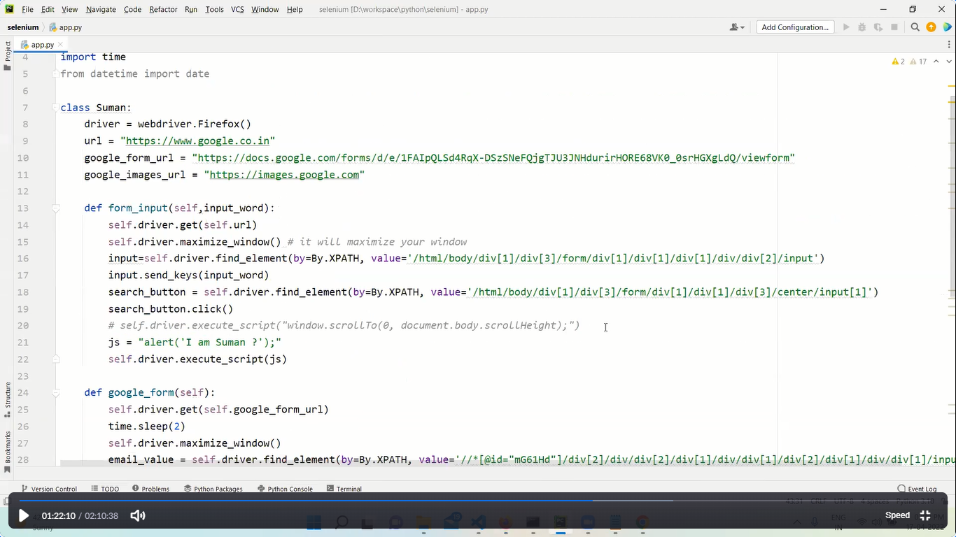

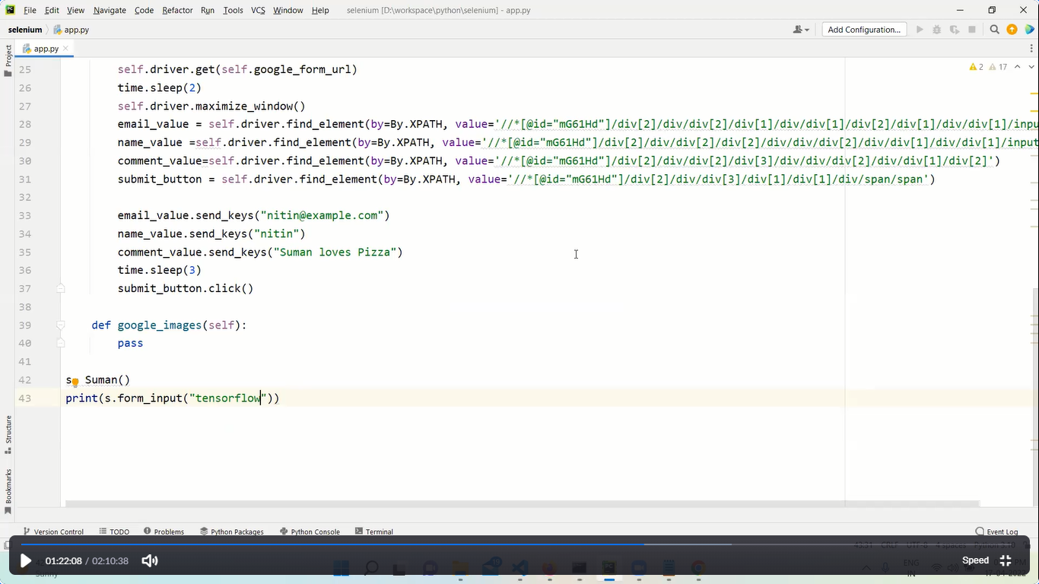

**************************************************************************

TASK



